***Computer Organization***

**Lab 7b Report**

***Names:***

**عبد الرحمن إسماعيل محمد حسن (22010866)**

**نور الدين اكرم السيد كامل سيف (22011309)**

**Introduction**

This project demonstrates the use of a temperature sensor to turn on an LED and fire up a buzzer when the temperature exceeds a certain limit.

**Implementation Setup**

* Arduino UNO microcontroller board.
* One red LED.
* One resistor (1 kΩ) to limit current to the LED.
* Temperature sensor (TMP36).
* Buzzer for audio alerts.
* Breadboard for building the circuit.
* Jumper wires for circuit connections.
* Arduino IDE for programming the microcontroller.

**Implementation Details**

* The Arduino continuously reads the analog input from the temperature sensor.
* The Arduino uses this formula to convert the read value of the sensor to degrees Celsius:

$$Temp \left(°C\right)=\left(\frac{analogRead\left(TEMP_SENSOR_PIN\right)}{1023}×5-0.5\right)×100$$

The read value of the pin is divided by 1023 and then multiplied by 5 to get the value of the voltage of the pin in Volts, then 0.5 Volt is subtracted to account for the TMP36 offset which gives it the ability to read negative temperatures, finally the result is multipled by 100 since there 100 °C in every volt read from the TMP36.

* If the temperature exceeds 30 °C the Arduino will turn on the LED, and fire up the buzzer, if the temperature goes back under 30 °C, the LED will be turned off and the buzzer will be stopped.

**Circuit Layout Diagram**

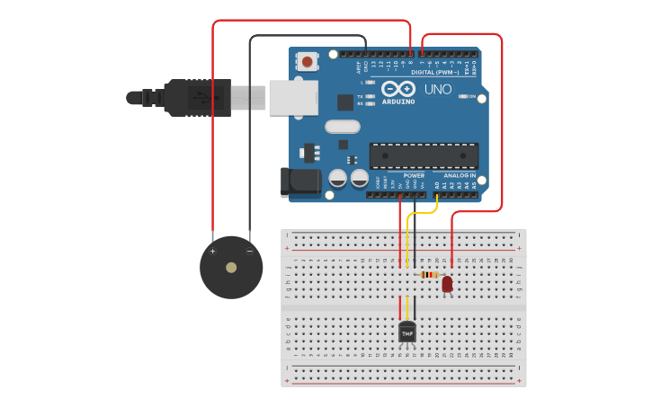

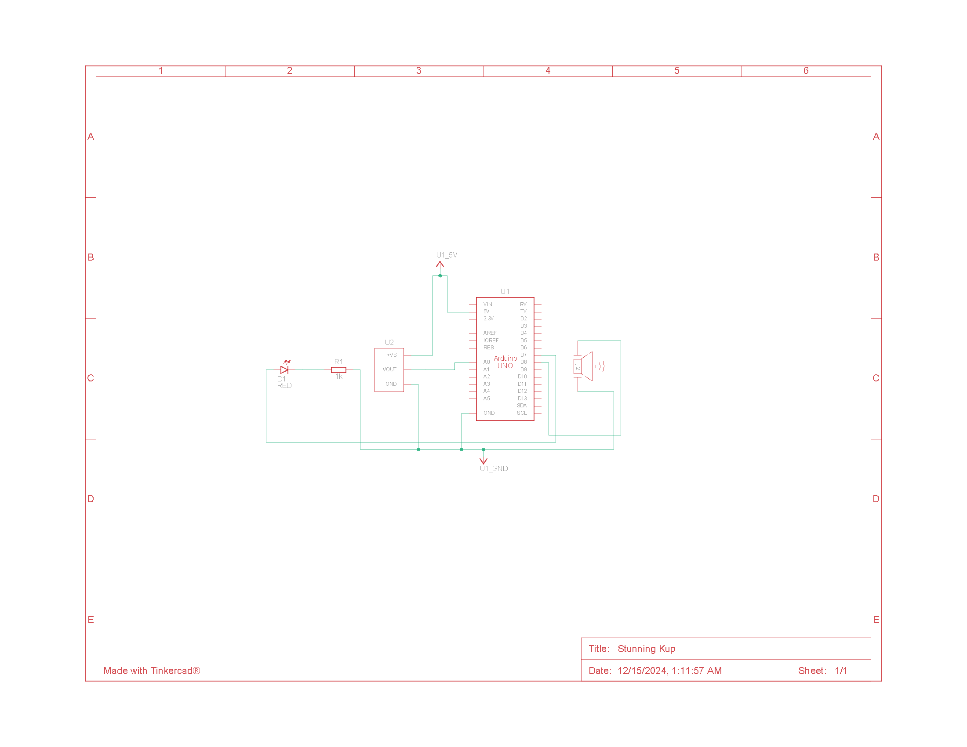**Circuit Schematic Diagram**